# Experiment 4: Simple Programs using RISC V Assembly (RARs tool)

|  |  |  |
| --- | --- | --- |
| **Sl No** | **Name** | **ID No** |
| **1** | **Vishwas Vasuki Gautam** | **2019A3PS0443H** |

**Exercise 5.1: Write RISC V assembly program to calculate the GCD of two numbers stored in data segment. Store the result back to data segment (use successive subtraction based Euclidean Algorithm).**

1. **Copy your image of assembly code for above exercise here.**

Answer: 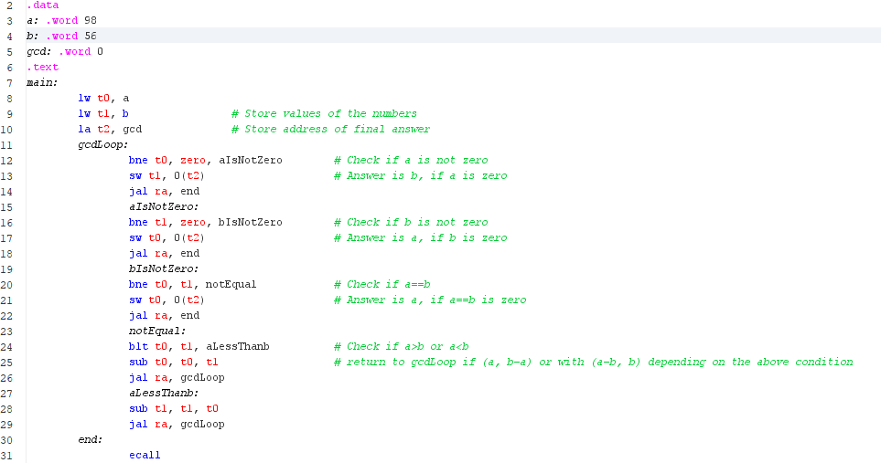

1. **Copy the image of data segment before execution and after execution. Copy the same in your observation book.**

Answer: **Before: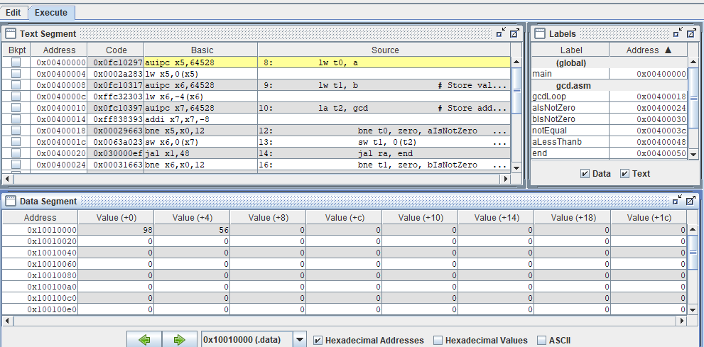 After:**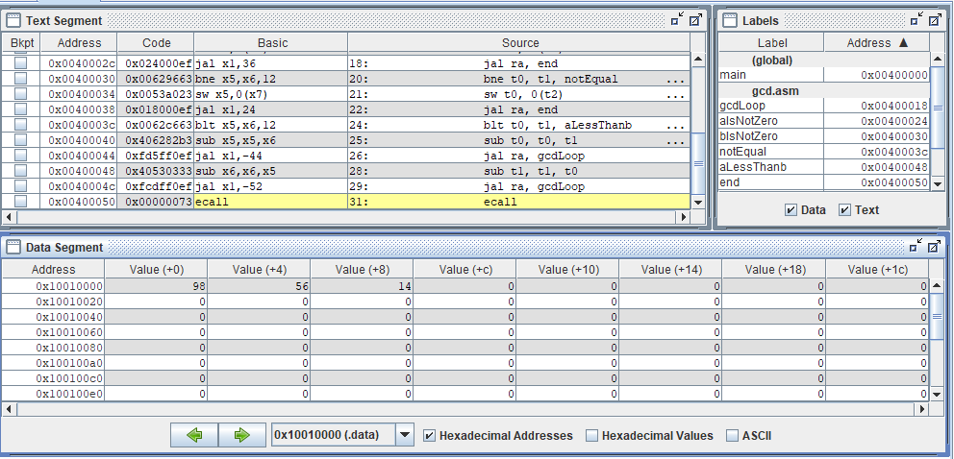

**Exercise 5.2: Write RISC V assembly code for generating N numbers of Fibonacci series in data segment. Assume that the value of N is stored in data segment. (Choose N value to be greater than or equal to 10d)**

For example: .data

N: .word 0x0a

fibseries: .word 0x0, 0x0, 0x0, 0x0, 0x0, 0x0, 0x0, 0x0, 0x0, 0x0

1. **Copy image of your assembly code for above exercise here.**

Answer: 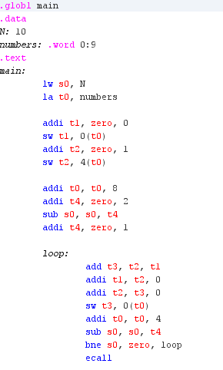

1. **Copy the image of data segment before execution and after execution for this program. Copy the inputs and outputs of this program in your observation book.**

Answer: Before:   
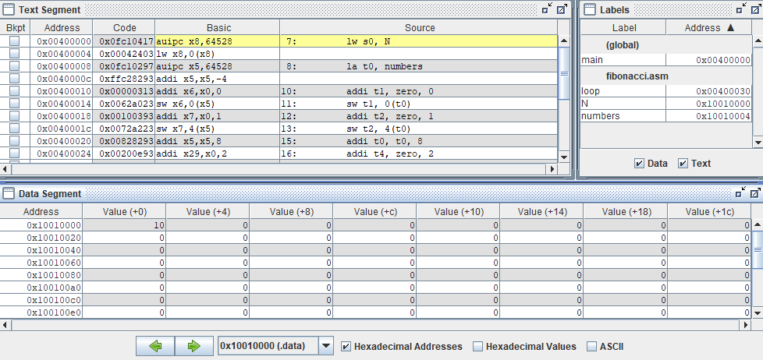  
  
After:   
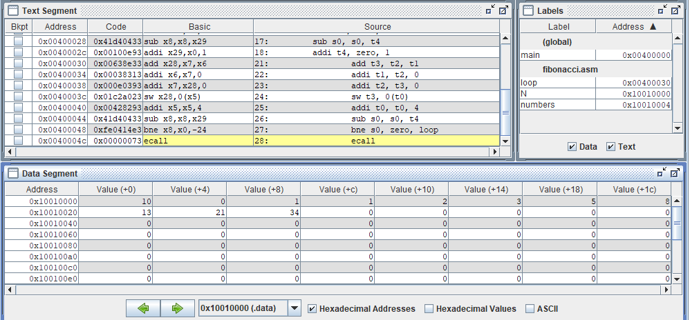

**Exercise 5.3: Try out all the new instructions discussed in class.**

1. **List the instructions that you have tried out (apart from lw, sw, add, addi, sub, beq, bne) Also list the concepts you learnt from this experiment.(Conlcusion/observations)**

Answer:used jal, la, blt as the new instructions in this experiment. The concepts learnt during this experiment are related to assembly programming. Branch, basic algebra, and other programming were implemented in assembly.